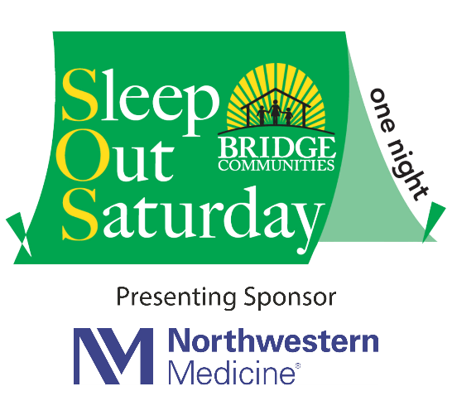

FOR IMMEDIATE RELEASE CONTACT:
Andrew Baumann
Andrew.baumann@bridgecommunities.org
630-403-5092

Family Homelessness Advocate and Author Diane Nilan to Speak at Sleep Out Saturday Rally on Nov. 2

Glen Ellyn, IL - September 30, 2024 - Bridge Communities is excited to announce that Diane Nilan, founder and president of the national homelessness nonprofit HEAR US and author of a new book about and for families facing homelessness, will be the special guest speaker at the 21st annual Sleep Out Saturday Kick-Off Rally on Nov. 2, 2024. The rally will take place at 6:30 to 8 p.m. in the north lot of College of DuPage's Culinary and Hospitality Center.

Recently, Nilan teamed up with a longtime colleague, Diana Bowman, founder and former director of the National Center for Homeless Education, to compile a vital guidebook for parents experiencing homelessness, “The Three Melissas – The Practical Guide to Surviving Family Homelessness.”

Nilan, a tireless advocate for family homelessness, brings decades of experience to the event. Her work with HEAR US gives voice and visibility to the over 7 million children and youth facing homelessness across America. Nilan's extensive background includes running shelters, working on statewide and national advocacy campaigns, and collaborating with educators to improve awareness of and compliance with homeless education laws that she helped pass.

The rally kicks off the 21st annual Sleep Out Saturday, one night during which hundreds of suburban Chicago residents will spend the night outdoors in tents, boxes, and cars. This powerful act of solidarity aims to raise awareness about family homelessness and funds for Bridge Communities' transitional housing and mentoring program.

The Sleep Out Saturday Kick-Off Rally, held in partnership with the College of DuPage, will feature live entertainment, prizes and giveaways, games, the moving story of a Bridge client, and food. All Sleep Out participants and members of the public are encouraged to attend this inspiring event before the overnight fundraiser begins.

This year's Sleep Out Saturday has set a fundraising goal of $125,000, which will directly benefit the more than 100 families served annually by Bridge Communities. The funds raised will support transitional housing, life-skills mentoring, financial counseling, employment training, tutoring, and children's services.

To sign up for Sleep Out Saturday or to donate to participants, please visit
www.sleepoutsaturday.org.

Bridge Communities is a non-profit 501(c)3 organization whose mission is to provide housing, mentoring and supportive services to families facing homelessness in DuPage County. Bridge Communities’ vision is a community where all families have safe, sustainable, and affordable housing and life-long self-sufficiency. In the past 36 years, Bridge Communities has helped more than 970 families cross the bridge from homelessness to hope and self-sufficiency. For more information, please visit www.bridgecommunities.org. Photos available upon request.

###

